Aneurin Bevan University Health Board
ACCESS STANDARDS 2019

A new set of standards were announced by the Minister for Health and Social Services in March 2019 that are aimed to raise and improve the level of service for patients in Wales from their GP practices.
These standards are set out below;

- People receive a prompt response to their contact with a GP practice via telephone.
- Practices have the appropriate telephony systems in place to support the needs of people avoiding the need to call back multiple times and will check that they are handling calls in this way.
- People receive bilingual information on local and emergency services when contacting a practice.
- People are able to access information on how to get help and advice.
- People receive the right care at the right time in a joined up way which is based on their needs.
- People can use a range of options to contact their GP practice.
- People are able to email a practice to request a non-urgent consultation or a call back.
- Practices understand the needs of people within their practice and use this information to anticipate the demand on its services.

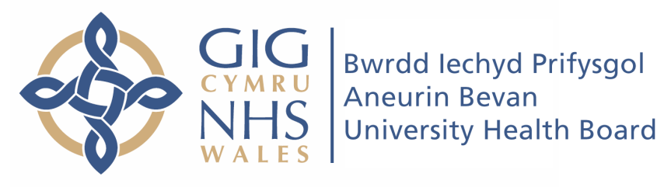
Aneurin Bevan University Health Board will be supporting your GP practice to ensure these standards are achieved by March 2021.

